

RIFT W260
Wireless WiFi Bluetooth Ceiling Speaker

User Manual

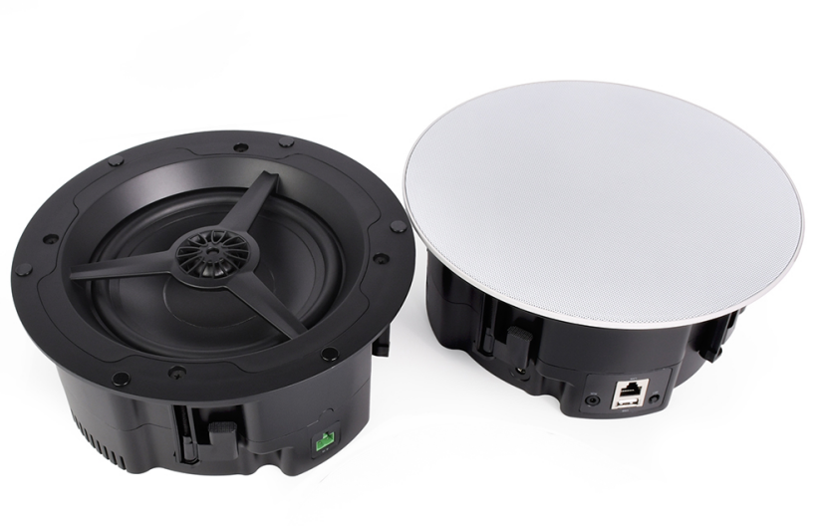

1.Overview
RIFT W260 wireless WIFI Bluetooth ceiling speaker supports dual-band WiFi and Bluetooth wireless connection. The speaker of the ceiling speaker is a 6.5-inch full-range speaker with a built-in tweeter, which can achieve 60~20KHz full-frequency coverage and SPL up to 90db , The DAC chip and power amplifier chip of the ceiling speaker are PCM5121 and TDA3116D2 from Texas Instruments respectively, and then the professional tuner divides the frequency of the sound and adjusts equalization of the sound. The layers are clear and the sound quality is outstanding.
RIFT W260 is divided into two speakers, a master and a slave. The slave one is a passive speaker, which is connected through speaker cable. The output power of the master and the slave is as high as 60W, which makes it be applied to a variety of occasions.
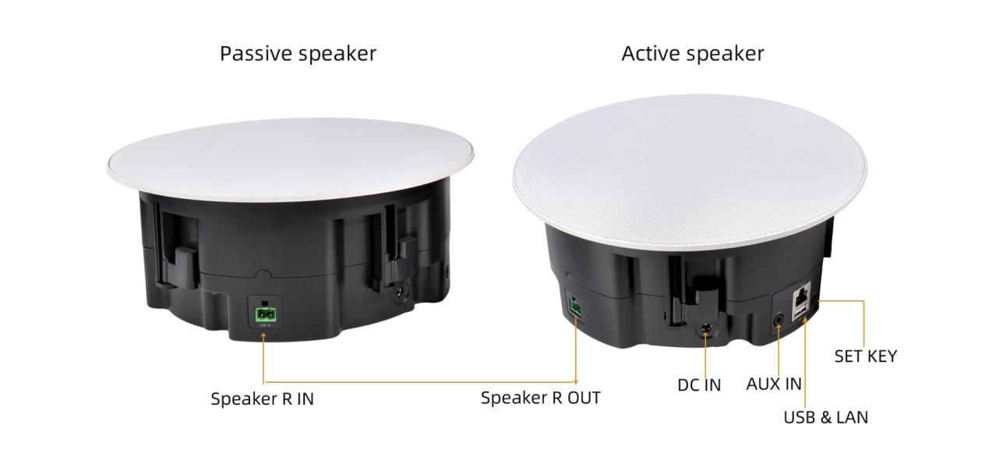
RIFT W260 wireless WIFI Bluetooth ceiling speaker also supports Apple's AirPlay function and the industry's device interconnection standard DLNA, which can wireless play music on devices such as iPhone, iPad or iPod touch through the AirPlay function, and can also use third-party DLNA- compliant A standard player to play music from an Android device or PC. Dual-band WiFi full-speed transmission, multi-experience HD music without delay.

Function Introduction
- Wi-Fi protocol: IEEE 802.11 a/b/g/n/ac 1x1 dual band WiFi 2.4 GHz and 5GHz
- Bluetooth protocol: Bluetooth 5.4 with EDR
- Support WiFi/Bluetooth/U disk playback/AUX
- Support APP interconnection control
- Support 10/100Mbps Ethernet access
- Support HTTP/HTTPS protocol
- Support Airplay/DLNA/Qplay streaming media protocol
- Support Airplay, Spotify, Bluetooth multi-room playback
- Support Spotify,Tidal,Yandex Music,Youtube Music,Apple Music, Qobuz, Tuneln etc.
- Support common lossless audio format decoding, up to 192kHz/24bit format
- Support MP3/AAC/WMA/FLAC/AIFF/ALAC/APE/WAV Decoders
- Support 433Mhz wireless RF remote control

2.Technical Parameters
Items | Descriptions
Product Name | Wireless WiFi Bluetooth Ceiling Speaker
Product Model | RIFT W260
Audio Input | WiFi 2.4G&5G / Bluetooth 5.4 / USB / AUX
Work Voltage | DC 24V-4A
Output Power | 60W×2（4Ω）(1Master+1Slave)
Frequency Response | 60Hz-20kHz
Harmonic Distortion | 0.05%
SNR | 90db
Sensitivity | 88±3db
Music Format | MP3/AAC/WMA/FLAC/AIFF/ALAC/APE/WAV Decoders
Music Source | Spotify,Tidal,Yandex Music,Youtube Music,  Apple Music,Qobuz,Tuneln etc.
Music Streaming Protocol | Airplay、DLNA、QPlay
Dimension | 23.5cm×9.7cm
Net Weight | 6.5kg (1Master+1Slave)

3.Structure Description
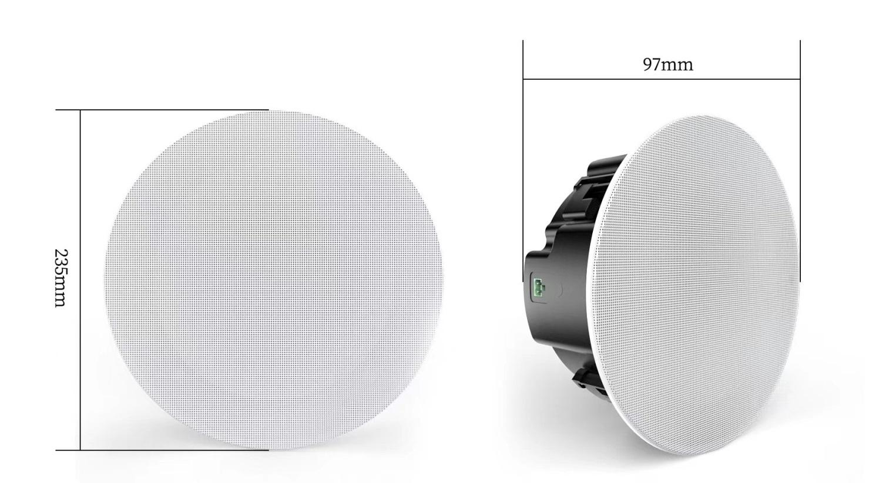
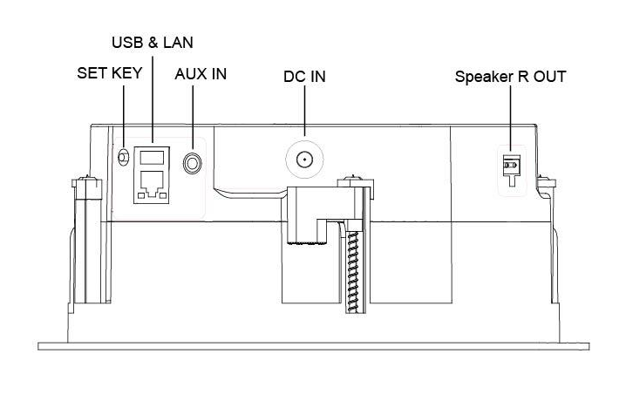
- Wireless Remote Control description
The wireless remote control uses a 433M wireless module, and the remote control distance is within 8 meters. RIFT W260 is equipped with a wireless remote control for one-to-one control.
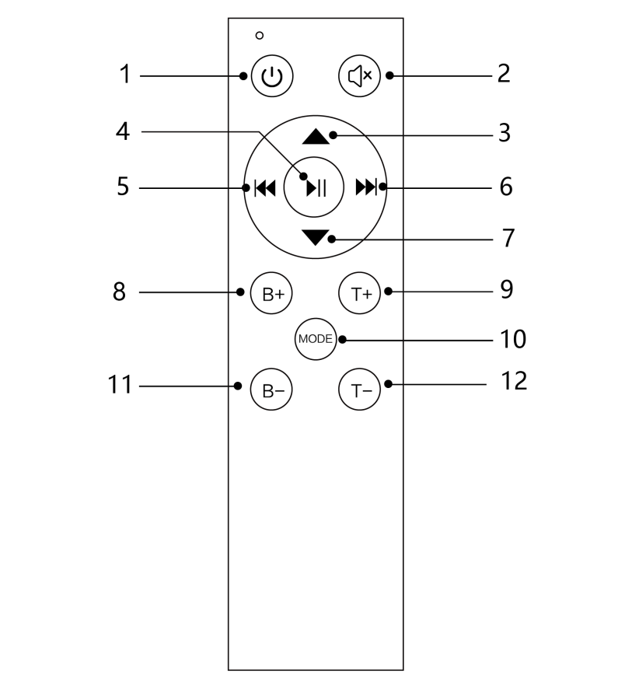
( Remote control )

NO. | Name | Features
1 | Standby key | Enter standby/Exit standby/long press to power off
2 | Mute button | Short press: Mute/Unmute  Long press: Factory reset
3 | VOL+ | Volume Up
4 | Play/pause | Short press: Play/Pause  Long press: WPS/Pair
5 | Previous song | Previous song  Long press: Wireless emission “Pairing”
6 | Next track | Next track  Long press: Wireless emission “Channel +”
7 | VOL- | Volume Down
8 | B+ | BASS UP
9 | T+ | TREBLE Up
10 | MODE | Short press to switch modes : (Network-->BT-->AUX-->USB),  Long press to reset system parameters
11 | B- | BASS down
12 | T- | TREBLE down
*Instructions for wireless remote pairing steps (the device has been paired before leaving the factory):
1. Short press the SET KEY on the back of the RIFT W260 three times in quick succession, and the speaker will announce "remote ready for paring"
2. Long press the standby button of the wireless remote control for 3 seconds until the speaker broadcasts "remote paired successfully", then the pairing is successful and the wireless remote control can be used.
3. Within powering on 1 minute, long press the standby button of the new wireless remote control for 5 seconds, until the speaker says "remote paired successfully", then the new wireless remote control is paired successfully.

*Wireless transmission: The wireless transmission function needs to be used with CS-320W, and the audio is sent to the CS-320W subwoofer through the wireless transmission module for playback (optional function)

5.Instructions for use
Please follow bellow instructions to use RIFT W260 WIFI Bluetooth Ceiling Speakers.
5.1 APP application
Please download the iAudioCloud from the APP Store or google play so as to use RIFT W260 ceiling speaker. The APP in the following document descriptions refers to the iAudioCloud.

iAudioCloud

5.2 Connection and installation
5.2.1 Ceiling Speaker connection
After taking out the RIFT W260 ceiling speaker, read the picture instructions of the product firstly.
Use speaker cable to connect the active ceiling speaker(the master) and passive ceiling speaker (the slave), plug Ethernet into the active ceiling speaker (if necessary), plug the matching power adapter into the DC socket to supply power to RIFT W260, and insert the USB with songs in advance if you need to play songs by USB.

5.2.2 Installation
When install the speaker, first remove the magnetic grille, put the speaker into the pre-opened speaker hole on the ceiling (hole size 215±5MM), open the buckles around the speaker and stuck in a suitable position, and then use a screwdriver to tighten the positioning screw , When the speaker surface is leveled with the ceiling, cover the net grille..

5.3 Start-up and configuration of network
After powering on the ceiling speaker with the adapter, and after hearing the speaker startup prompt, open the APP on your smart mobile phone, and follow the APP prompt to link the ceiling speaker to the wireless network (as shown in the figure below). The speaker can also be connected to the Ethernet at the same time. Ethernet has priority in connection.
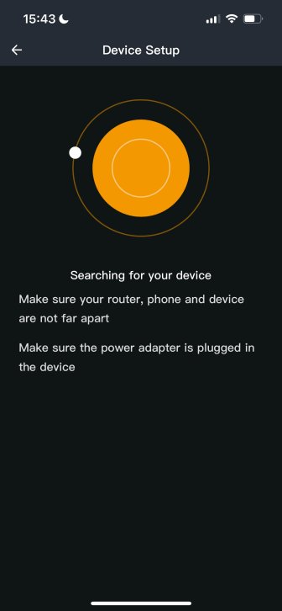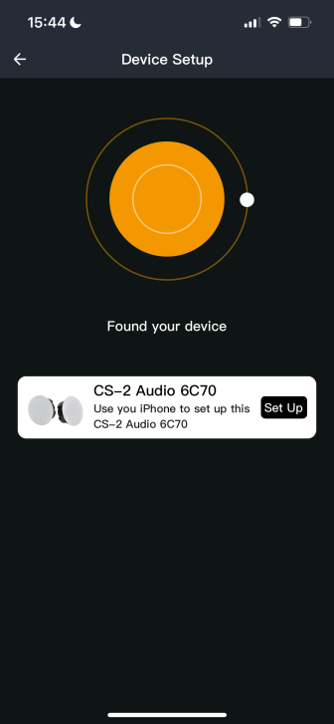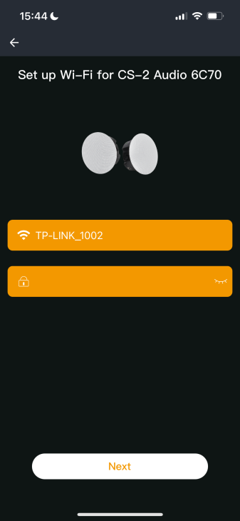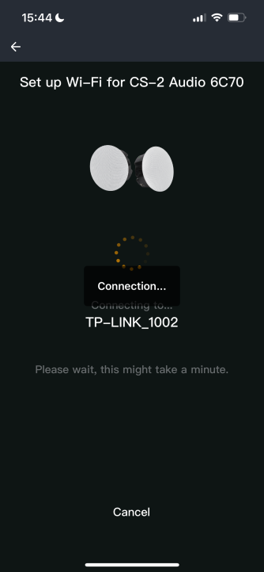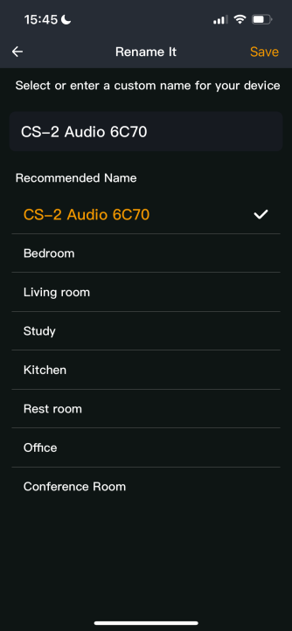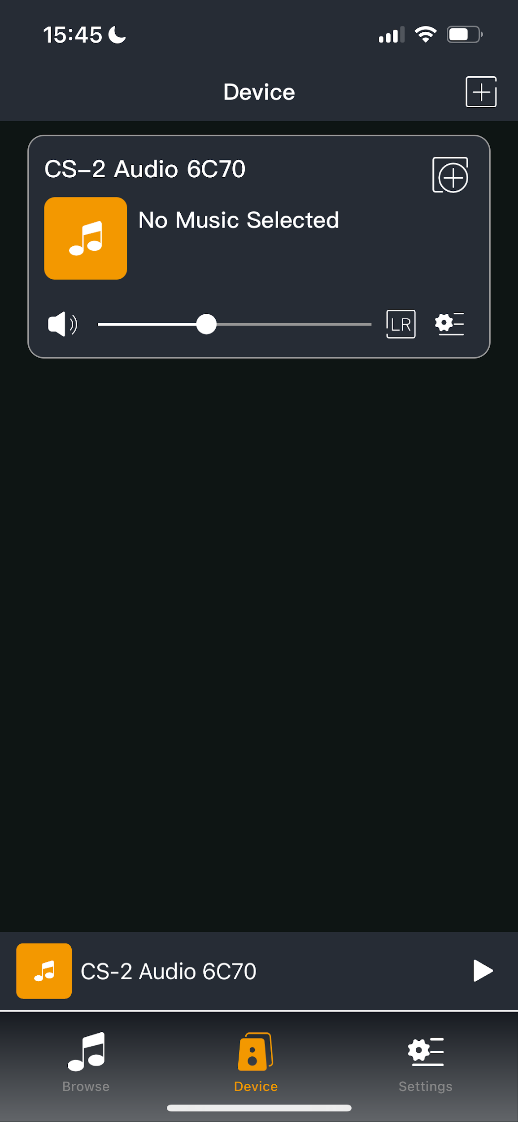

5.4 Prompt and Operations
5.4.1 Voice prompt description
The RIFT W260 ceiling speaker will send a voice prompt to remind the user during use. The user might use the RIFT W260 ceiling speaker according to the voice prompt. The voice prompt descriptions are as follows:
- When the source is switched, "WiFi Mode" "Bluetooth Mode"AUX Mode" "Udisk Mode" will be prompted.
- In WiFi setting mode and Bluetooth pairing/disconnecting, prompt sound of “setting” or ”connection” will be sent out.

5.4.2 APP display instructions
After the RIFT W260 is connected to the network, you can check the work status of the RIFT W260 on the APP (as shown in the picture below), including play progress, song information, and volume.

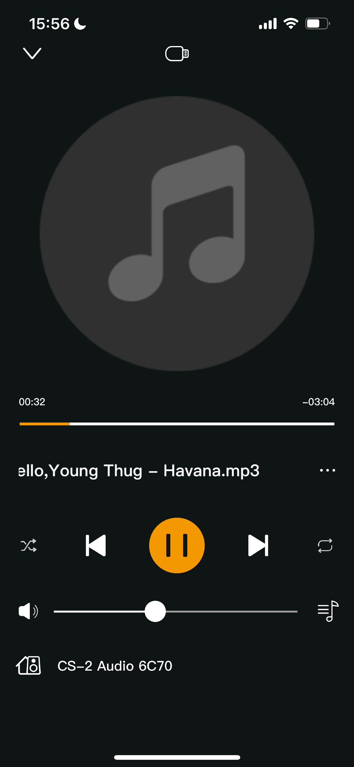

5.4.3 Operation instructions
- Standby and wake-up: When RIFT W260 is working, short press the standby button on the remote control to control the RIFT W260 to enter standby and stop the music; when the RIFT W260 is in standby, short press the standby button on the remote control or select the song to play in the APP or Select Source to wake up RIFT W260.
- Power off: When the RIFT W260 is working, long press the standby button on the remote control to control the RIFT W260 to power off and enter the low power consumption mode.
- Network configuration and pairing: When RIFT W260 is working, if you need to change the wireless network for RIFT W260, you can press and hold the playback pause button on the remote control in the Network mode or press and hold the SET KEY in the back of casing for 2 seconds to release the WiFi hotspot, and reconfigure the wireless network for RIFT W260; In BT Mode, long press the playback pause button on the remote control or long press the SET KEY on the back casing for 2 seconds to disconnect the current Bluetooth connection and re-enter the pairing status.

- Source switching: When the RIFT W260 is working, you can short press the MODE button on the remote control or switch the Source on the APP. The cycle sequence of the MODE button Source switching is WiFi->BT->AUX->USB; select Source in the APP as shown below:
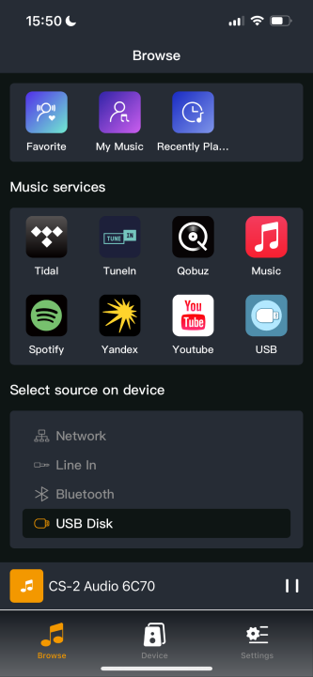

- Volume adjustment: The volume of the RIFT W260 can be adjusted through remote control and APP. The output gain of the ceiling speaker changes with the volume level and is displayed on the APP volume bar (as shown in the figure below).
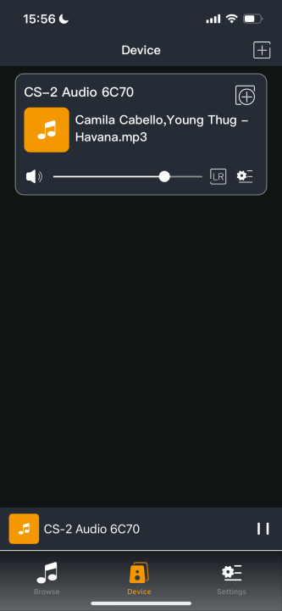

- Audio operation: When the RIFT W260 is working, you can control previous/next song, play and pause on the APP or by remote control, and can also directly select and play local music in the APP, or the music list of the USB Disk (as shown in the figure below). Support dragging the playback progress on the APP and switching the playback mode (such as random playback).
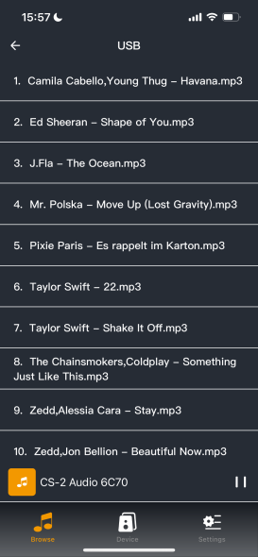
- BASS/TREBLE adjustment instructions: RIFT W260 can use the remote control to adjust BASS and TREBLE. There are 10 BASS/TREBLE levels for adjustment, and the positive and negative gains are 5db respectively. The power amplifier output will change with the adjustment.
- Parameter reset: Long press the MODE button of the remote control to reset the system parameters of the RIFT W260, and reset the BASS, TREBLE and volume to the factory default state.

- Restore factory settings: In the Device interface of APP, Select the Device 🡪Enter the setting 🡪Device information. RIFT W260 can be operated to restore factory Settings (as shown below), or long press the SET KEY on the back shell for 5 seconds. Reset the system parameters to the factory default state, and clear the wireless network and Bluetooth connection information.
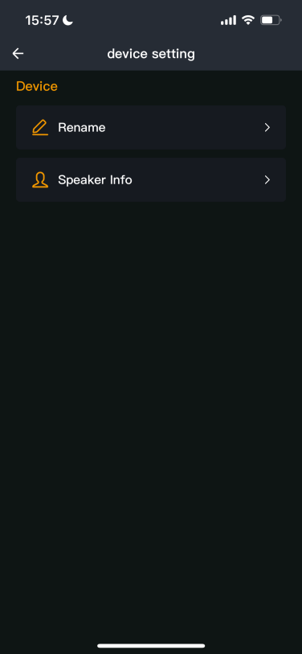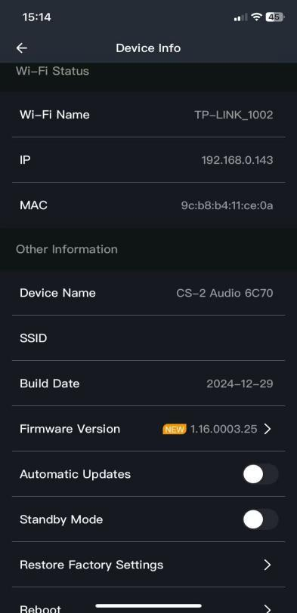

6.Parts list
NO. | Name | Qty
1 | RIFT W260 Active Ceiling Speaker(Master) | 1pcs
2 | RIFT W260 Passive Ceiling Speaker(Slave) | 1pcs
3 | Power cord | 1pcs
4 | Wireless remote control | 1pcs

